**Sprint 3 Plan**

**Meme Feed**

**Meme Teme**

**2/12/19**

**Revision 0**

**Goal:**

For this sprint, our goal is to involve friendships so that way users can see which memes there friends like as well as implement the direct messages that users will want to have.

**Task Listing:**

(1) As a user, I want to be able to see a Friend Feed which displays memes my friends liked. **(14)**

* Have a page for Friend feed that is defaulted to list view. **(2)** *(Emma)*
* Have a header with buttons for both views to change the full and grid view. **(2)** *(Emma)*
* Pull memes from firebase that the user’s friends have liked and sort them in chronological order. **(6)** *(Zac)*
* Repurpose list view and grid view for friend feed **(2)** *(Emma)*
* Lazy loading of feed **(2)** *(Mia)*

(2) As a User, I want to visit a user’s page so I can see my only friends posts **(14)**

* When clicking on a users icon be routed to their page **(7)** *(Zac)*
* Have a user page with header follower count etc **(3)** *(Siddhi)*
* Load that users likes from firebase in chronological order **(2)** *(Zac)*
* Have list and grid view for this page **(2)** *(Siddhi)*

(3) As a User, I want to be able to be able to follow with people so I can see the memes they post **(7)**

* Implement functionality to have the follow button on person add that user (p’) to user p ‘s entry in firebase. (p’ is the non active user) and (p is the active user) **(6)** *(Jon)*
* Increment p ‘s number of following and p` ‘s number of followers **(1)** *(Jon)*

(4) As a User, I want to be able search and look up someone else’s page, to see only their content **(16)**

* Have a search bar at the top of general feed with a scrollable area to show search results. **(6)** *(Siddhi)*
* Implement the firebase functionality of the search typing a name and the results appearing in the search results. **(9)** *(Jon)*
* Pressing search results should redirect to person’s profile. **(1)** *(Zac)*

(5) As a User, I want to comment on posts to share my opinion on them. **(16)**

* Have a component for single comments that shows user name of commenter **(3)** *(Zac)*
* Text area to write comments **(2)** *(Mia)*
* When commenting that comment is sent to firebase on that post **(5)** *(Mia)*
* When viewing a post all the comments are loaded **(5)** *(Mia)*
* Sort loaded comments by time **(1)** *(Mia)*

(6) As a user, I want the General Feed page to have two different views so that I can view at a different pace **(8)**

* Ability to tap on a meme in grid view and have it go to a full view of just that singular meme **(3)** *(Emma)*
* Have the ability to scroll through a single feed to see more memes **(5)** *(Emma)*

(7) As a User, I want my own account page where people can see the memes I like (personal user page) **(5)**

* Repurpose list view for memes **(2)** *(Siddhi)*
* Sort liked memes from firebase chronologically by react time **(3)** *(Jon)*

**Team Roles:**

**Mia:** Product Owner, Developer

**Emma:**  Developer

**Siddhi:**  Developer

**Zach:**  Developer

**Jon:** Scrum Master, Developer

**Initial Task Assignment:**

**Mia:**

(1) As a user, I want to be able to see a Friend Feed which displays memes my friends liked. **(14)**

* Lazy loading of feed **(2)** *(Mia)*

(5) As a User, I want to comment on posts to share my opinion on them. **(16)**

* Text area to write comments **(2)** *(Mia)*
* When commenting that comment is sent to firebase on that post **(5)** *(Mia)*
* When viewing a post all the comments are loaded **(5)** *(Mia)*
* Sort loaded comments by time **(1)** *(Mia)*

**Emma:**

(1) As a user, I want to be able to see a Friend Feed which displays memes my friends liked. **(14)**

* Have a page for Friend feed that is defaulted to list view. **(2)** *(Emma)*
* Have a header with buttons for both views to change the full and grid view. **(2)** *(Emma)*
* Repurpose list view and grid view for friend feed **(2)** *(Emma)*

(6) As a user, I want the General Feed page to have two different views so that I can view at a different pace **(8)**

* Ability to tap on a meme in grid view and have it go to a full view of just that singular meme **(3)** *(Emma)*
* Have the ability to scroll through a single feed to see more memes **(5)** *(Emma)*

**Siddhi:**

(2) As a User, I want to visit a user’s page so I can see my only friends posts **(14)**

* Have a user page with header follower count etc **(3)** *(Siddhi)*
* Have list and grid view for this page **(2)** *(Siddhi)*

(6) As a User, I want my own account page where people can see the memes I like (personal user page) **(20)**

* Repurpose list view for memes **(2)** *(Siddhi)*

(4) As a User, I want to be able search and look up someone else’s page, to see only their content **(16)**

* Have a search bar at the top of general feed with a scrollable area to show search results. **(6)** *(Siddhi)*

**Zac:**

(1) As a user, I want to be able to see a Friend Feed which displays memes my friends liked. **(14)**

* Pull memes from firebase that the user’s friends have liked and sort them in chronological order. **(6)** *(Zac)*

(2) As a User, I want to visit a user’s page so I can see my only friends posts **(14)**

* When clicking on a users icon be routed to their page **(7)** *(Zac)*
* Load that users likes from firebase in chronological order **(2)** *(Zac)*

(4) As a User, I want to be able search and look up someone else’s page, to see only their content **(16)**

* Pressing search results should redirect to person’s profile. **(1)** *(Zac)*

(5) As a User, I want to comment on posts to share my opinion on them. **(16)**

* Have a component for single comments that shows user name of commenter **(3)** *(Zac)*

**Jon:**

(3) As a User, I want to be able to be able to follow with people so I can see the memes they post **(7)**

* Implement functionality to have the follow button on person add that user (p’) to user p ‘s entry in firebase. (p’ is the non active user) and (p is the active user) **(6)** *(Jon)*
* Increment p ‘s number of following and p` ‘s number of followers **(1)** *(Jon)*

(4) As a User, I want to be able search and look up someone else’s page, to see only their content **(16)**

* Implement the firebase functionality of the search typing a name and the results appearing in the search results. **(9)** *(Jon)*

(7) As a User, I want my own account page where people can see the memes I like (personal user page) **(5)**

* Sort liked memes from firebase chronologically by react time **(3)** *(Jon)*

**Initial Burn Up Chart:**

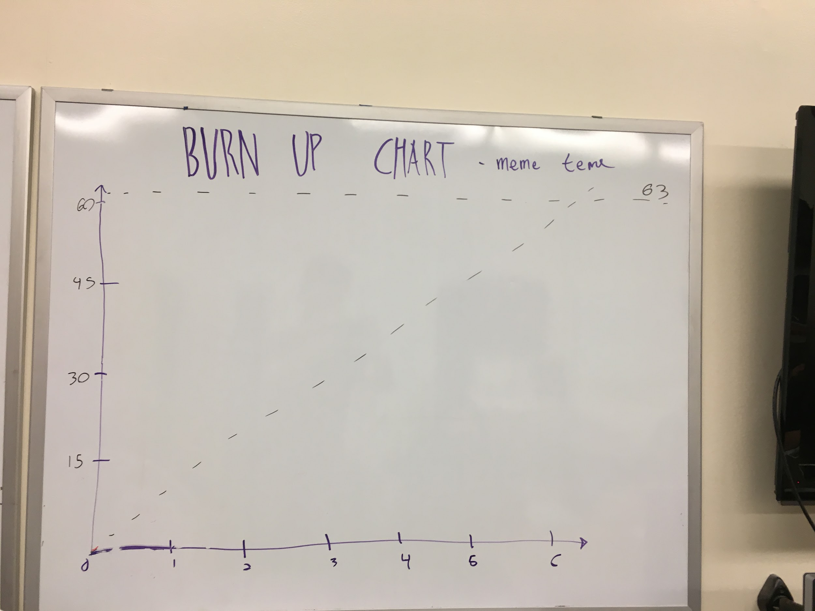

**Initial Scrum Board:**

